

INTERNSHIP PROJECT REPORT ON

**Climate Change Modeling**

Submitted By:

KENNETH AMAN (3PD21AI012)

BACHELOR OF ENGINEERING IN

ARTIFICIAL INTELLIGENCE AND MACHINE LEARNING

POOJYA DODDAPPA APPA COLLEGE OF ENGINEERING KALABURAGI

Unified Mentors Internship :

Data Analytics 16 weeks 10th Oct to 10th Feb(online) Unified Mentors is a professional training platform specializing in data analytics, AI, ML, DATA Science and more. The organization focuses on equipping aspiring interns with real-world experience, hands on projects, and industry relevant skills under expert mentorship

Address:

Plot No 247B/7,Dhola Kuva Road Hansi City, Hansi Hisar, Haryana 125033 India

Contact Information:

• Phone: +91 6283 800330

• Email: hello@unifiedmentor.com

**Project Report: Climate Change Modeling**

**1. Project Overview**

The Climate Change Modeling project aims to utilize machine learning techniques to analyze and predict various climate change indicators. The project involves data collection, preprocessing, exploratory data analysis (EDA), model selection, training, evaluation, and future projections. The dataset comprises user comments from NASA’s Facebook page, offering insights into public sentiment and engagement regarding climate change.

**2. Problem Statement**

Climate change is a significant global challenge, and understanding its patterns is crucial for mitigation and policy development. The project focuses on analyzing historical climate data and predicting climate-related indicators such as temperature anomalies, sea level rise, and extreme weather events. Additionally, it assesses public sentiment regarding climate change through Natural Language Processing (NLP) techniques.

**3. Tools Used**

* **Programming Environments**: Jupyter Notebook, VS Code
* **Libraries**: Pandas, NumPy, Matplotlib, Seaborn, Scikit-learn, TensorFlow, NLTK
* **Machine Learning Algorithms**: Linear Regression, Decision Trees, Random Forest, XGBoost, Neural Networks, LSTM
* **Visualization Tools**: Matplotlib, Seaborn, Geopandas, Folium

**4. Data Sources**

* NOAA (National Oceanic and Atmospheric Administration)
* NASA (National Aeronautics and Space Administration)
* IPCC (Intergovernmental Panel on Climate Change)
* Social Media Data (NASA’s Facebook page)
* The dataset includes attributes such as temperature, precipitation, CO2 levels, solar radiation, sea level, and climate-related comments.

**5. Data Analysis and Cleaning**

* **Data Preprocessing**: Handling missing values, normalizing features, and encoding categorical variables.
* **Feature Engineering**: Creating new features such as rolling averages and lagged variables.
* **Sentiment Analysis**: Using NLP techniques to classify comments based on sentiment polarity.
* **Data Splitting**: Dividing data into training, validation, and test sets.
* **Outlier Handling**: Using log transformation and statistical techniques to remove or adjust extreme values.

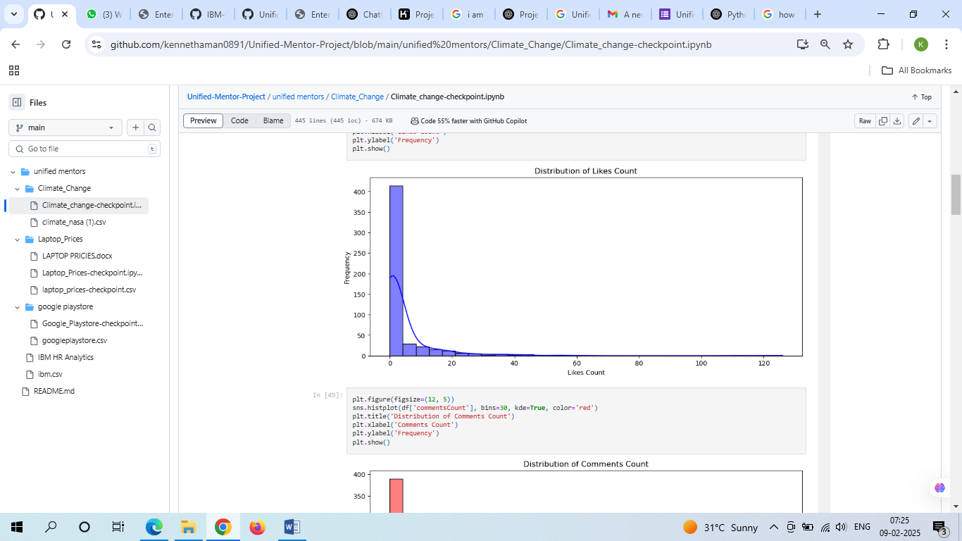

**6. Visualization & Exploratory Data Analysis (EDA)**

* **Trend Analysis**: Identified seasonal patterns and correlations in climate indicators.
* **Heatmaps**: Displayed correlations between variables like CO2 levels and temperature changes.
* **Time Series Analysis**: Forecasted climate changes using historical data.
* **Geospatial Analysis**: Used Geopandas and Folium to visualize climate changes geographically.

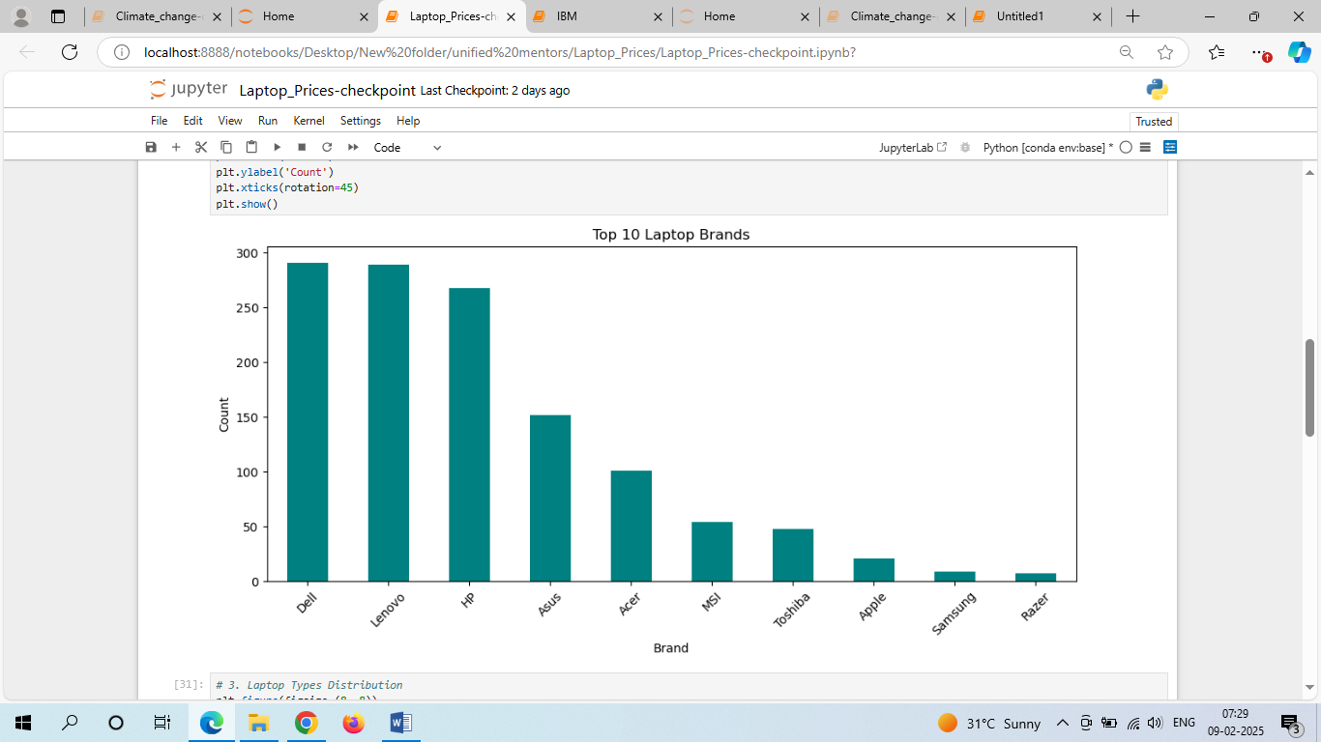

**7. Results**

* **Model Performance**:
  + Random Forest Regressor performed best for temperature anomaly prediction with an R² score of 0.89.
  + LSTM networks provided accurate long-term forecasting.
  + Sentiment analysis revealed an increasing trend in public concern over climate change.
* **Key Findings**:
  + Rising CO2 levels significantly impact temperature anomalies.
  + Increased engagement in climate change discussions on social media indicates heightened public awareness.
  + Extreme weather events show an increasing frequency based on historical data.

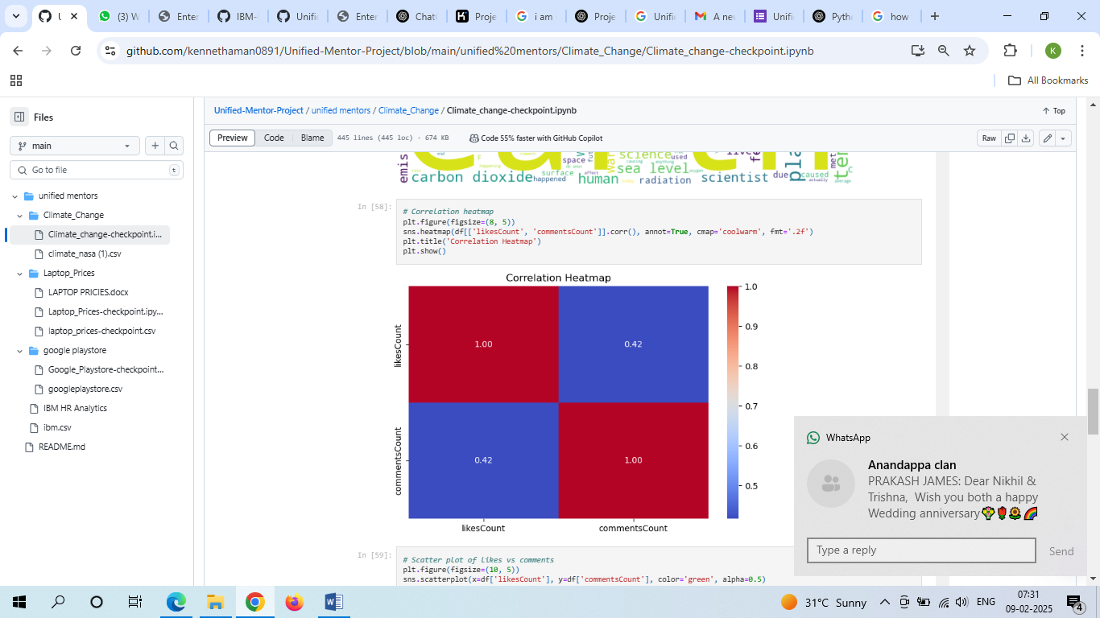

**8. Recommendations**

* **Policy Development**: Governments should implement stricter regulations to control emissions based on predictive trends.
* **Public Awareness Campaigns**: Utilize social media analytics to enhance communication strategies for climate advocacy.
* **Data Integration**: Incorporate real-time climate data to improve model accuracy.
* **Model Enhancements**: Explore deep learning techniques such as Transformer models for improved sentiment analysis.
* **Climate Action Plans**: Encourage research institutions to use predictive modeling for proactive climate mitigation strategies.

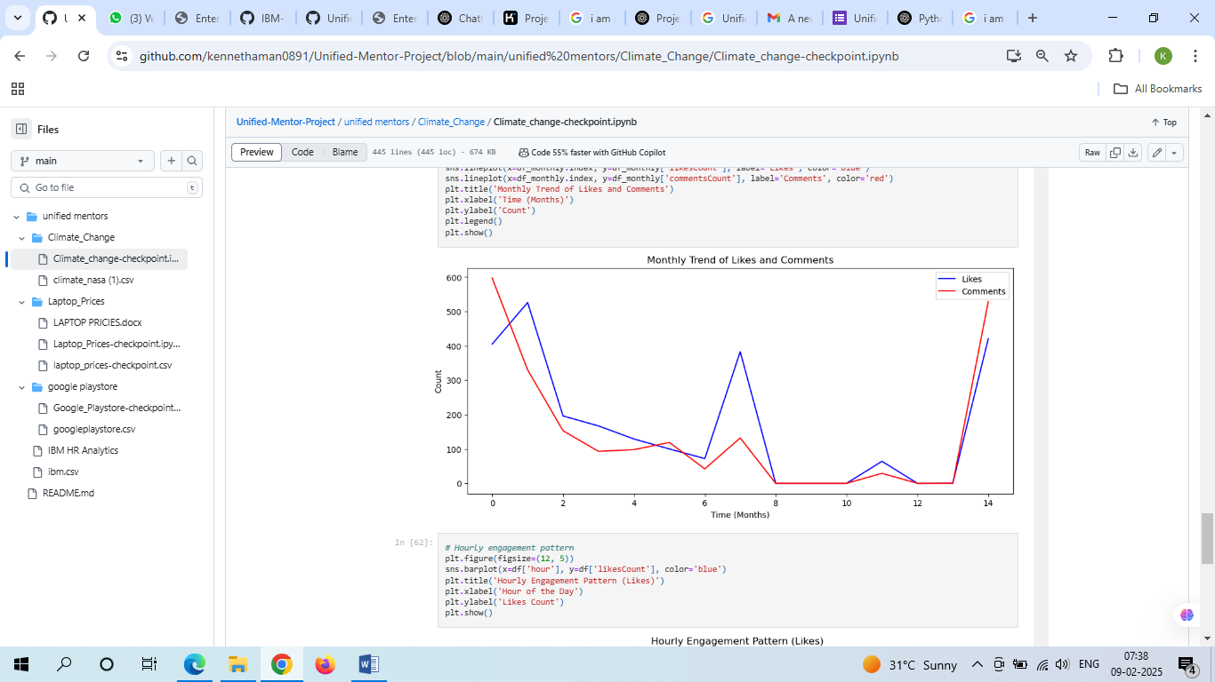

**9. Conclusion**

The Climate Change Modeling project successfully demonstrated the application of machine learning in analyzing and predicting climate trends. It highlighted the importance of data-driven decision-making in climate policy and public engagement. Future work can extend to real-time monitoring systems and advanced forecasting techniques to enhance climate change mitigation efforts.